Title: How can new mothers rebuild pelvic floor strength?
Keywords: pelvic floor recovery, postpartum exercises, Kegel exercises, women’s health, childbirth recovery, pelvic floor muscles, new mothers, postpartum care.
Short Description:
After childbirth, many women experience pelvic floor weakness that can cause leaks, discomfort, or a heavy feeling “down there. This is a guide to help new mothers regain pelvic floor strength after childbirth through gentle exercises, daily habits, and proper care.

How can new mothers rebuild pelvic floor strength?
After childbirth, most women focus on their baby’s health and forget their own recovery.
Yet beneath all that joy and exhaustion, the pelvic floor, the group of muscles that supports the bladder, womb, and bowel, has gone through a serious workout.
Many new mothers notice small leaks when they laugh, sneeze, or lift things, or feel a heavy, dragging sensation down below.
Pregnancy and childbirth stretch these muscles far beyond their usual limit, and while your body is incredibly strong, it also needs time and the proper care to bounce back.
Let’s take a look at what actually happens to the pelvic floor after childbirth.
What Happens to the Pelvic Floor After Birth
During pregnancy and childbirth, the pelvic floor carries a lot of weight.
These muscles form a hammock-like support beneath your bladder, womb, and bowels, and they stretch to make way for your baby during delivery.
After birth, they can feel weak or “loose,” and that’s completely normal.
Here’s why:
- Pressure from pregnancy: Carrying a growing baby for nine months puts continuous strain on the pelvic muscles and ligaments.
- Vaginal delivery: Carrying a big baby or pushing for too long can overstretch or even tear the pelvic floor tissues.
- Episiotomy or tearing: These can affect muscle coordination and healing.
- Hormonal changes: The hormone relaxin, which loosens ligaments for childbirth, can leave muscles feeling less firm even after delivery.
- C-section recovery: Even women who didn’t deliver vaginally may experience weakness; pregnancy itself places pressure on the pelvic region.

How to Rebuild Pelvic Floor Strength Safely
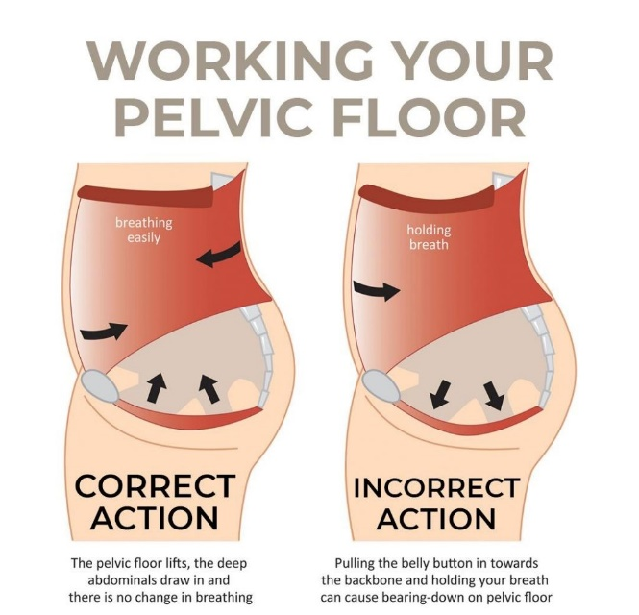
Recovering your pelvic floor isn’t about doing a hundred “tighten-and-hold” moves in one day; it’s about consistent rebuilding. Here’s how to start safely:
1. Start with Awareness
Before jumping into exercises, first reconnect with your pelvic floor.
Sit or lie down, take a deep breath, and imagine gently lifting the muscles you’d use to stop yourself from passing urine or gas. That subtle squeeze is your pelvic floor working.
Tip: Never practice stopping your urine mid-flow regularly, it’s just for awareness, not exercise
2. Do Gentle Kegel Exercises
These are small but powerful movements that help your muscles recover control.
- Tighten your pelvic floor muscles for 3–5 seconds, then relax for the same amount of time.
- Repeat this 8–10 times, two or three times daily.
- As you get stronger, try holding for longer.
- Avoid squeezing your thighs, buttocks, or holding your breath; it’s all about focus and control.
3. Add Deep Breathing
Breathing deeply from your belly (not your chest) helps your pelvic floor relax and contract naturally.
When you inhale, your pelvic floor softens; when you exhale, it gently lifts. This connection helps the muscles heal without strain.
4. Gradually Include Functional Moves
Once cleared by your doctor, you can add light strengthening exercises that support pelvic recovery, like:
- Bridges: Lying on your back with knees bent, lift your hips slowly and squeeze your pelvic floor.
- Mini squats: Keep your back straight and engage your core as you lower down gently.
These moves retrain the coordination between your core and pelvic floor, helping you feel stronger from within.
Everyday Habits That Support Pelvic Floor Healing
- Don’t ignore the urge to pee: Holding urine for too long can strain already tired muscles. Go when you need to.
- Avoid pushing or straining in the toilet: If you struggle with constipation, add more water, fruits, and fibre-rich foods like pawpaw, oats, and vegetables.
- Lift carefully: When carrying your baby or heavy items (like a water bucket or groceries), bend your knees, tighten your pelvic floor slightly, and exhale as you lift.
- Watch your posture. Slouching can weaken your core and pelvic support. Sit upright with your back supported and feet flat on the floor.
- Stay hydrated: Many new mums drink less to avoid leaking, but dehydration worsens constipation and bladder irritation.
When to See a Specialist
Sometimes, despite doing all the right things, the pelvic floor still needs extra help, and that’s okay.
You should see a pelvic health or women’s physiotherapist if you notice:
- Leaking urine or stool that doesn’t improve after a few months.
- A heavy, dragging feeling in your vagina (especially after standing for long).
- Pain during sex or when inserting a tampon.
- Difficulty controlling gas or feeling like “something is falling out” or bulging in your vagina.
- You’re unsure if you’re doing Kegels correctly (many women unknowingly do them the wrong way).
A specialist can assess your pelvic floor strength, check for prolapse, and guide you through tailored exercises and techniques for faster recovery.
Early attention prevents long-term issues, and most women see real improvement within weeks of starting therapy.
In Conclusion
Your body has done something incredible: it’s carried, birthed, and nurtured new life. It deserves grace, patience, and care in return.
Healing takes time. You don’t have to rush or push yourself to feel “normal” again. Just pay attention to your body.
Have you tried any pelvic floor or postnatal recovery exercises before? I’d love to know what worked for you, or what challenges you’ve faced since childbirth.
Share your thoughts in the comments.

Researched by Victoria Odueso

